First we need to check if iscsi-initiator-utils and device-mapper-multipath packages were installed in the client machine.

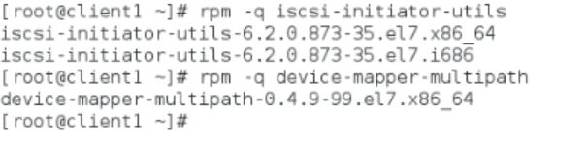

Server IP:

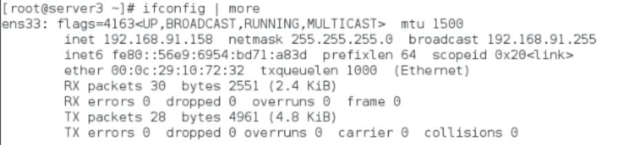

At first I have checked if there is any active path available and as there are no active paths nothing is displayed. Then I have discovered using iscsiadm command and server IP address



Now, copy paste the Initiator name in /etc/iscsi/initiatorname.iscsi file and restart the service

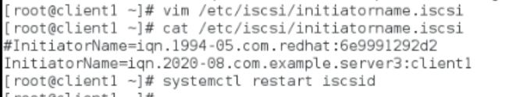

Now, logged into the lun which we have created in the server and enabled the multipath services

We need to comment the following lines in multipath.conf file

After that I have checked for available luns to the machine and added the wwid number which we got in multipath.conf file

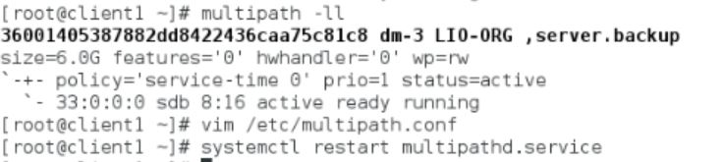

Below is the content which I have updated in multipath.conf file

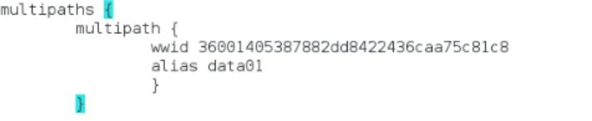

Later, I have checked if the disk space is available or not using fdisk -l

